Wireshark: UDP

## BSDSF22A001 – Muhammad Rehan

2. **Packet Number:** 197

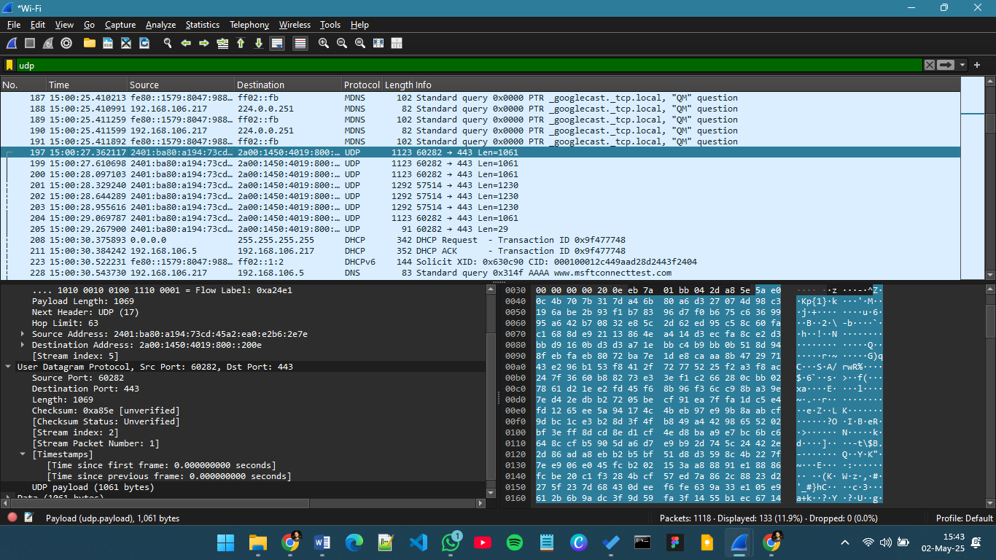

1. **Protocol Message:**



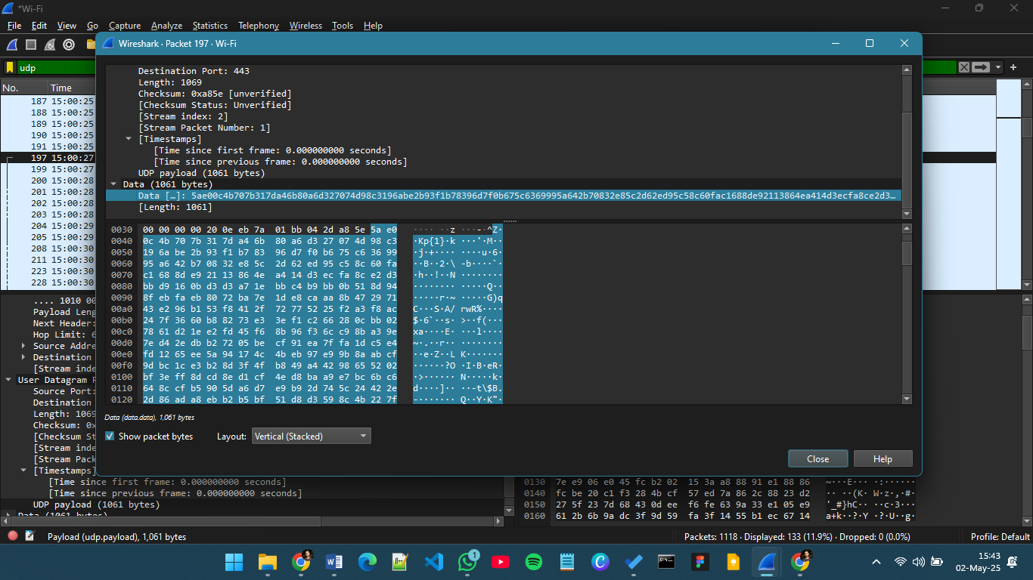

1. **No. of header fields:** 4
2. **Names of fields:**
3. **Source Port** (udp.srcport)
4. **Destination** (udp.dstport)
5. **Length** (udp.length)
6. **Checksum** (udp.checksum)

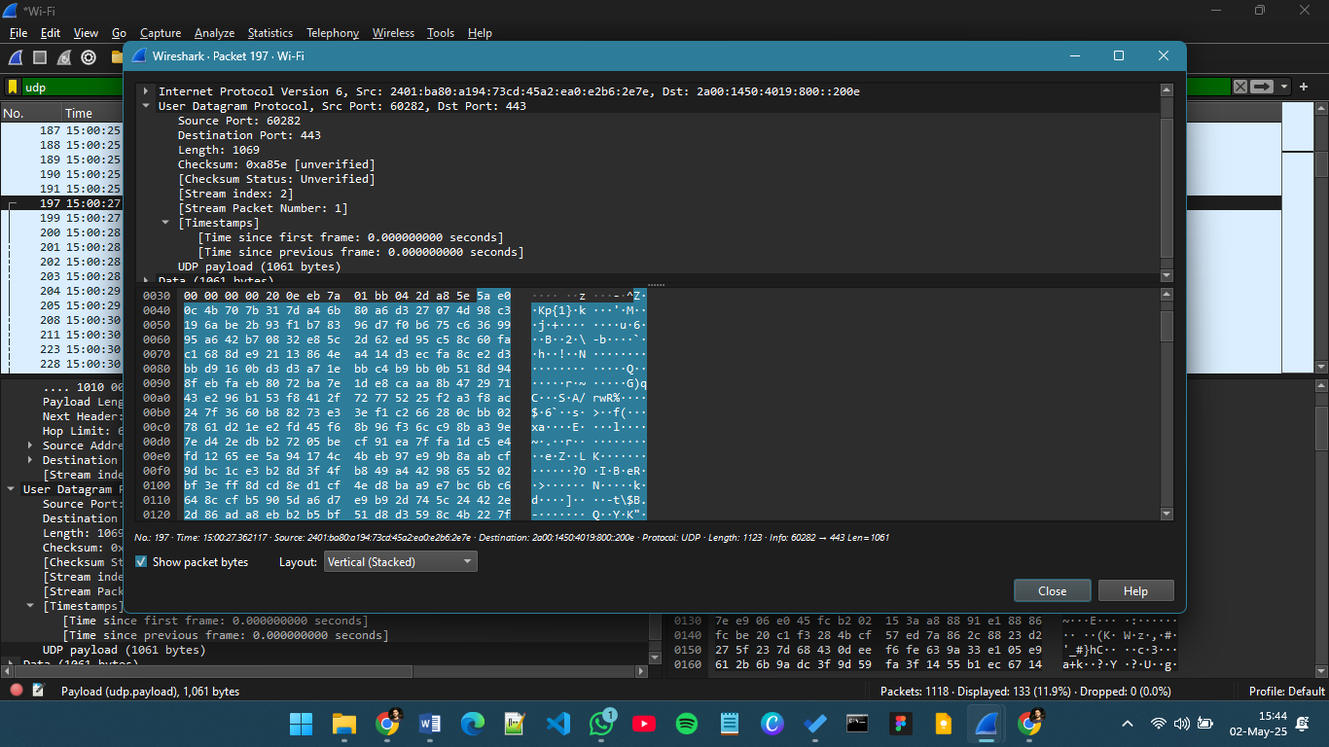

1. Each UDP header field is **2 bytes (16 bits)** long. With 4 fields—Source Port, Destination Port, Length, and Checksum—the total UDP header size is **8 bytes**.
2. The Length field indicates the total size of the UDP segment (header + payload). In my captured packet, the Length is **1069 bytes**, and the UDP header is **8 bytes**, so the UDP payload is **1069 − 8 = 1061 bytes**, which matches the payload shown in Wireshark.
3. The maximum size of a UDP segment is **65,535 bytes**. Subtracting the 8-byte header, the maximum UDP payload is **65,527 bytes**.
4. The Source Port field is 16 bits, so the largest possible source port number is **65,535**.
5. The **protocol number for UDP** is **17** in decimal notation.

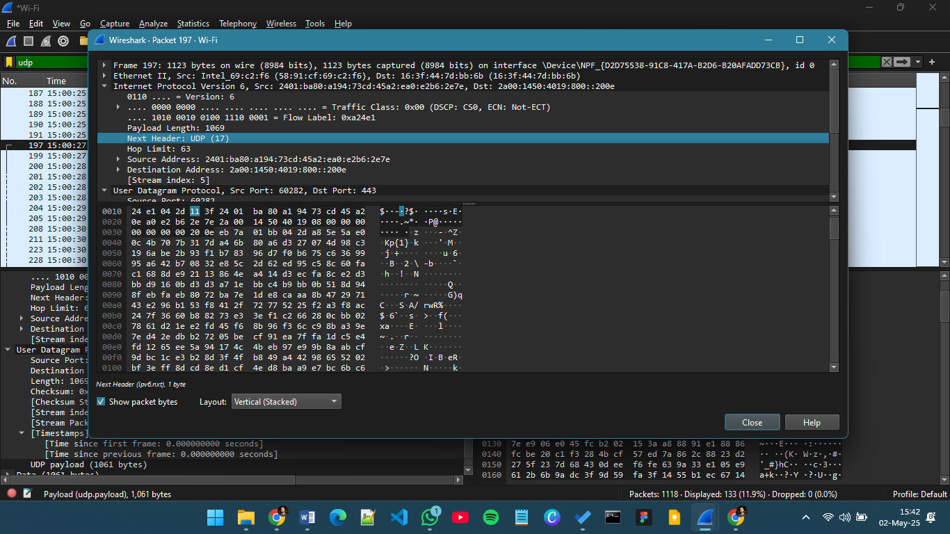

1. In my trace file, the **first UDP packet** is **Packet Number 197**, and the **second UDP packet** is **Packet Number 270**. The **source port (60282)** of the first packet is the **destination port** of the second packet, and the **destination port (443)** of the first packet is the **source port** of the second packet, which shows the reply relationship between the two packets.

